C5_2

setwd(".")  
library(knitr)  
library(sqldf)

## Loading required package: gsubfn

## Loading required package: proto

## Loading required package: RSQLite

Apartado a)

# A buena hora  
pnorm(50,25.5,5.1)

## [1] 0.9999992

pnorm(50,25.5,5.1)*240

## [1] 239.9998

# Tarde  
1-pnorm(50,25.5,5.1)

## [1] 7.77939e-07

1-pnorm(50,25.5,5.1)*240

## [1] -238.9998

Apartado b)

La probabilidad de que tarde al menos 30 min

pnorm(30,25.5,5.1)*240

## [1] 194.6897

Apartado c)

# Si sale a las 8:26, la probabibilidad de que llegue tarde será  
1-pnorm(34,25.5,5.1)

## [1] 0.04779035

Gráfico de la distribución normal

mean<-25.5  
sd<-5.1  
x <- seq(-5, 5, length=100)*sd+mean  
hx <- dnorm(x, mean, sd)  
  
plot(x, hx, type="l", xlab="Tiempo (min)", col="red",  
 main="Tiempo de llegada al trabajo", lwd = 2,  
 ylab="Densidad")  
grid()  
  
lb<-20.4  
ub<-30.6  
filtro<-x>=lb&x<=ub  
lines(x, hx)  
polygon(c(lb,x[filtro],ub), c(0,hx[filtro],0), col="red")

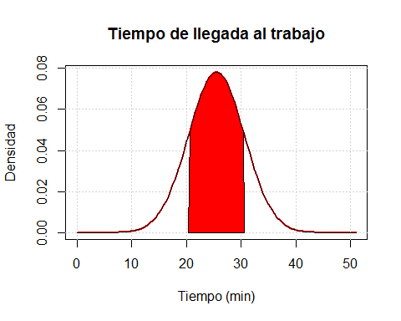

zonaprob<- (pnorm(ub, mean, sd) - pnorm(lb, mean, sd))*100  
zonaprob

## [1] 68.26895